1. **HOME**

* Banner slider or Banner image.( Product images images)
* What we do

1. BUILDING SINCE 2017

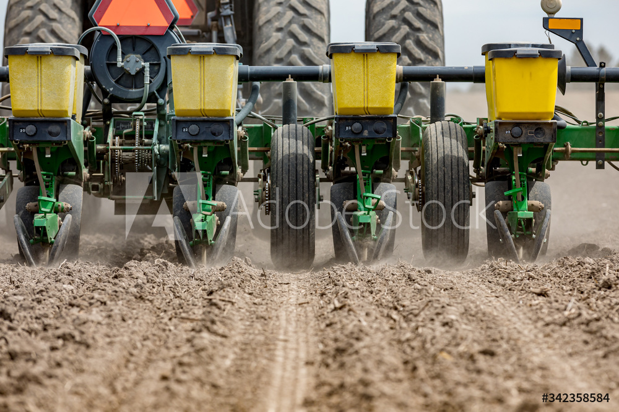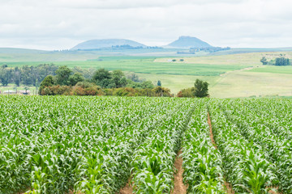

* Synthafric Ghana Company limited went under strategic thinking and as an idea to be realized on 18th June, 2017 which was the first big step ever taken by a group of young Entrepreneurs(the fabulous 4). The idea was recognized by our reputable partners( MHM ASIA) and was fronted by a member of the team(Fab4).

In 2018, Synthafric Gh. Co. reached Its full recognition and criticism. This created a way to officially document every strategies together to pull out a great business plan for 3 to 5 years. This took place in Accra Kempinski hotel together with the CEO of MHM Mr. Marcel Jahnke.

After a successful planning with great impressive results, the Fab4 together with the board of MHM agreed to proceed with the company registration on 4th March, 2019.

READ MORE (connected to about us page)

1. GREAT LOGISTICS

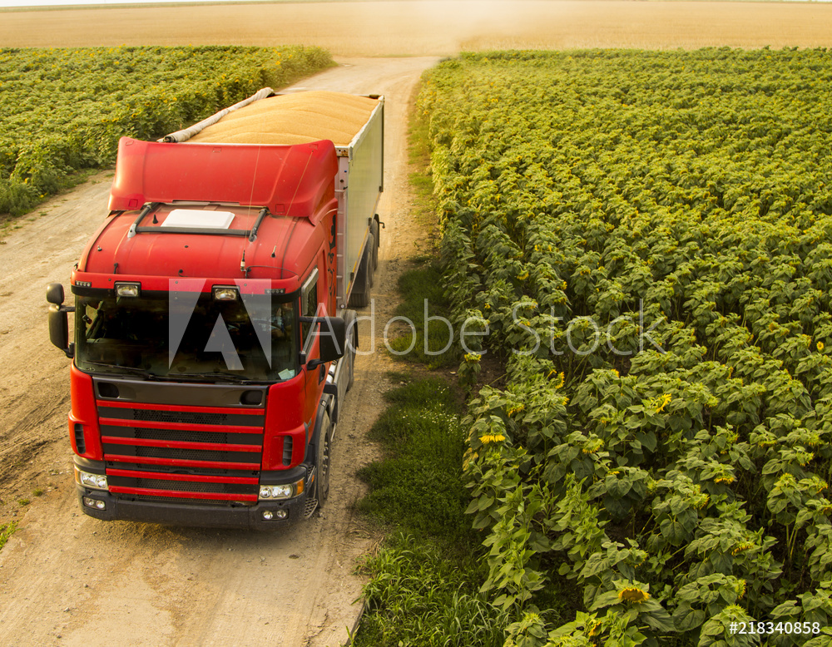

* We work with professional logistic personals to ensure safe and careful handling and delivery of Synthafric farm produce. All Product are neatly bagged and kept in a very serine environment.

We have long and short loading vehicles that do timely delivery on specific days base on our working hours(link to contact us page).

We do great delivery and handling of purchased farm produce at an affordable price. We also do free delivery on large orders to both companies and individuals. (You are welcome to request a price quote for free. Contact now (link to contact us page)

1. QUALITY FARM PRODUCE

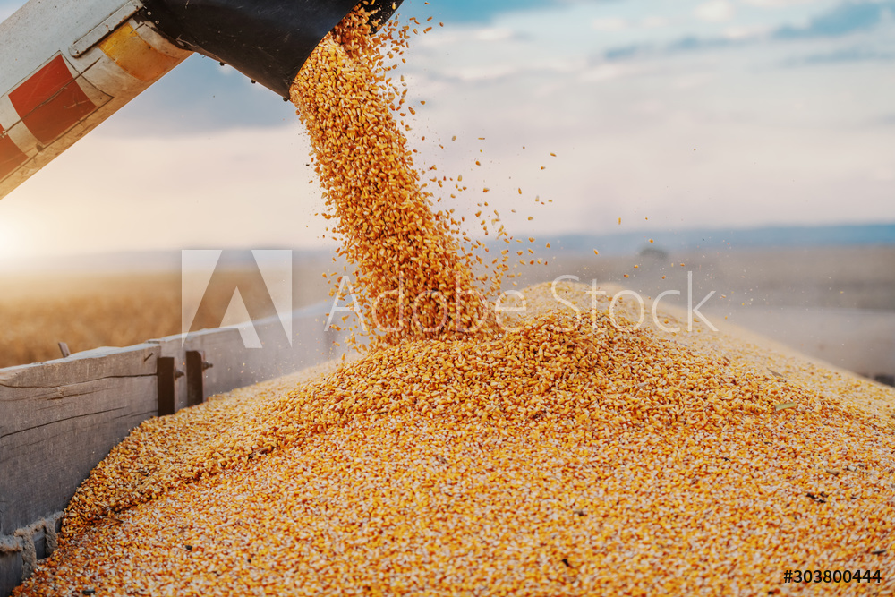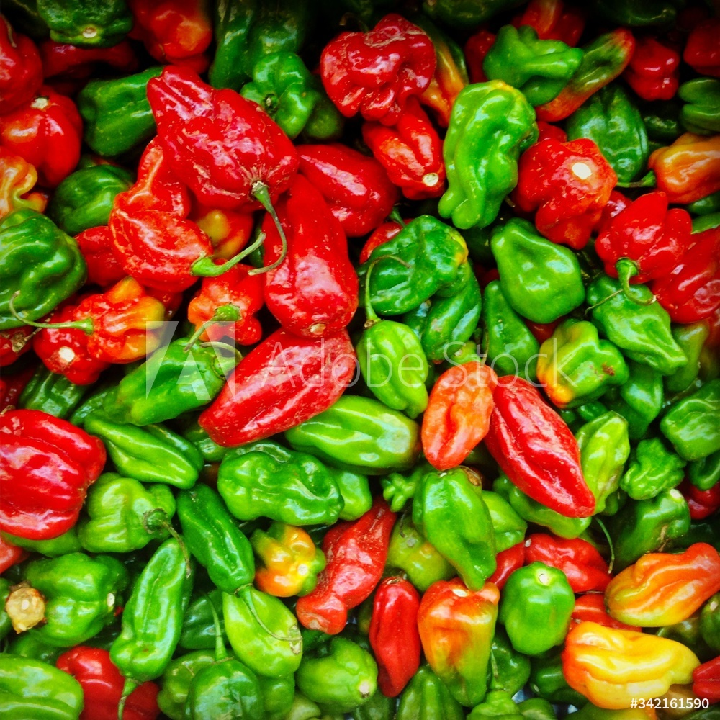

* + We work with wide range of powerful machineries to ensure quality and healthy farm produce. Farm products are directly harvested and processed In a confined warehouse with serine environment.

All hygienic farm protocols and Practice Practices are ensured to meet the FDA and export standard. Read more (link to product description page.)

1. **ABOUT US**



 Research shows that maize is one of the largest consumed commodity in Ghana and in most African countries. Nevertheless, most of the maize farmers are peasant farmers. This has created a big gap between supply and demand.

This brought up the idea to bridge the gap between the demand and supply of the widely consumed commodity in the region.

Synthafric

As a startup with some background in agriculture, and seeing the potential in the farming or agricultural industry, A group of young graduates [James Brown Quaye (Agronomist), Prince Appiah (Crop Scientist), Richard Quansah (Economist), Ishmael Lamptey (Economist), Thompson NIi Ayensu (Computer Engineer), Prince Botchway (strategic communicator)] made a decision to venture into maize farming. Overcoming obstacles was not easy because of our little knowledge in the field. Visiting the drawing board several times we eventually solved the problems of the kind of seed, the fertilizer, the machineries and labor we needed for the project.

Synthafric aims to be a reliable source of farm produce in West Africa. We also aim to be one of the greatest company who educates peasant farmers and young entrepreneurs who also have visions to help develop the country and continent.

Helvetica

* **Young and Energized team**

In every aspect of life, the perfect and quality thing are mostly required and that is why Synthafric has made it priority and a need to penetrate into the market with young and energized team with great ambition.

* **Good network( A network image )**

Synthafric has great range of Networks Building and extending all various sectors of Agriculture both locally and International. We value our partner and keep moving together.

We have Great networks from reputable countries in Asia and Europe.

## Mission ( A network image )

It is Synthafric mission to become the leading provider of purely organic and inorganic farm crops to the citizens and also train other entrepreneurs in the African Region. This will be accomplished by providing quality crops while exceeding customer's expectation and also learning more on the job.

## Objectives

Synthafric has identified several objectives for the business:

* Become a leading supplier of organic and inorganic farm produce for the populace in the African region.
* Reach the point of sustainable profitability.
* Create a business hub for other young entrepreneurs.
* Enjoy work while making a good living.

1. **Our Team**



1. 

**James Brown Quaye ( Director of Operation & Projects)**

J.B. Quaye is a very hard working young man, a team player and a motivated person who is always ready for new challenges with the ability to learn and adapt quickly to new and changing environments.

As a bachelor degree holder in agronomy, He has keen interest and a passion for plants and animals.

1. 

**Ishmael Lamptey ( Director of Logistics & Distribution).**

Mr. Ishmael L. is an enthusiastic leader who excels in motivating others to achieve great results in all economical aspect. He is an expect in customer management with great problem solving techniques.

Mr.Ishmael L. is a degree holder in international economics, a team player with advanced knowledge in the field of consultancy.

1. 

**Mr. Thompson Nii Ayensu ( Director of Marketing, I.T & BizSolutions).**

Mr. T.N. Ayensu is a hard working personnel with great personalities who Provides room for originality and perfection in the field of active business managements and problem solving. Assertive and enthusiastic, with extensive knowledge in computer Engineering.

Mr. T. N. Ayensu is a graduate with expertise providing basic solutions in special entire business contributions. Exceptional computer aptitude, great etiquette and 5 years extensive technical background.

1. 

**Richard Quansah( Director of Finance & HR.)**

Mr. R.K. Quansah is a Bachelor degree graduate in International Economics. A team player who is always ready to learn and also a quick learner. Acquired Knowledge in various business fields like Accounting, Management, Marketing, Branding.

Throughout his education and stay in foreign Countries, He has gained some skills in IT, organization, communication and also learnt how to work with a team.

1. 

**Prince Appiah (Assistant Farm Manager)**.

Mr. Prince A. is an experienced agricultural professional with expertise in tasks such as crop management and fertilization, farm equipment maintenance and management, and field cultivation.

He has excellent ability to apply agricultural skills to practice and yield excellent results from work. Prior experience farming in various capacities, including root crop, cereals and vegetable farm, and orchard settings.

Mr. Prince A. took on managerial roles in prior positions and supervised progress in agricultural tasks completed by other workers. Successfully doubled yield for crops while managing farm and oversaw a 40 percent increase in profits from sales.

1. 

**Prince Botchway (Secretary**)

Mr. P.N. Botchway is a highly organized and efficient person with thorough and precise approach to projects which will yield results for the esteemed organization. Able to manage own time effectively and prioritize work load.

Mr. P.N. Botchway is experienced at working to meet deadlines and under pressure. Friendly and approachable with excellent Interpersonal and client relation skills.

1. **CONTACT US**



* Banner slider or Banner image.( contact images)
* Working hours.
* Monday to Thursday : 8:00 AM to 4 PM
* Friday : 8:00 AM to 3 PM
* We are available for assistance (h2 header)

1. Do you need any help or more information? Please contact us here.

(mail emoji). Email us : [info@synthafric.com](mailto:info@synthafric.com)

(phone emoji)Phone. : +233243719296

+233543428468

1. Please contact our sales department for our prices and purchases.

(mail emoji). Email us : [sales@synthafric.com](mailto:sales@synthafric.com)

(phone emoji) Phone. : +233243719296

+233545999457

* Footer

Address: 13B Treba str. Ga- West, Accra - Ghana.

1. **STAY INFORMED**

**Local News**

“All local news will be sourced from this links for now until we reach the educational state where we will be giving out our own news feeds.”

**Links :** MOFA : <http://mofa.gov.gh/site/>

ESOKO : news on pricing <https://esoko.com/food-prices-in-ghana-april-2020/>

**Synthafric News**

May be you create a template to be used in posting news.

**Resource**

**Blog**

1. **PRODUCT DESCRIPTION** 
   * Banner or slides( Production images )

Synthafric has chosen some plant species that have significant market demand as wellbeing, well suited for growth in the Pakro Village. Synthafric will feature: Maize – a cereal that is mostly consumed in the African region for various meals; Pepper - a source of vitamin. Synthafric Ghana offers a range of farm crops and animal rearing. Farm crops were chosen for two main reasons. The first is the consuming rate. The second reason is for it being part of the day to day food and raw materials for the processing industry.

* + Production cycle
* Harvesting - drying – Grading & bagging – handling – delivery 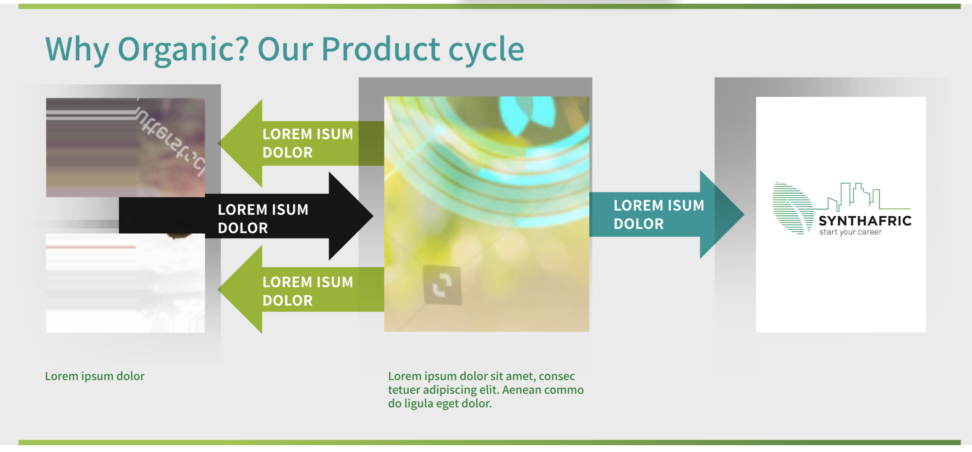
* Product details:

GRADING STANDARDS FOR MAIZE

|  |  |  |  |  |
| --- | --- | --- | --- | --- |
| PARAMETER | G1 | G2 | G3 | G4 |
| Moisture content | 13% | 13% | 13% | 13% |
| Insect damage | 1% | 3% | 5% | 7% |
| Rotten, diseased & Discolored | 2.5% | 5% | 6.5% | 10% |
| Immature/Shrivelled grain | 1% | 2% | 3% | 5% |
| Total Defective Grains | 4.5% | 10% | 14.5% | 22% |
| Broken Grain | 2% | 4% | 6% | 10% |
| Foreign matter( earth, sand and stones) | 0.5% | 1% | 1.5% | 3% |
| Live infestation | None | None | None | None |
| Inorganic matter | 0.25% | 0.5% | 0.75% | 1.5% |

The Grading standards for maize adopted by some commodities exchanged in Ghana for 2019.

GRADING FOR MAIZE (SYNTHAFRIC)

|  |  |  |  |  |
| --- | --- | --- | --- | --- |
| PARAMETER | G1 | G2 | G3 | G4 |
| Moisture content | 13% | 13% | 13% | 13% |
| Insect damage | 0.25% | 2% | 3.5% | 6.3% |
| Rotten, diseased & Discolored | 0.75% | 3% | 6% | 7.5% |
| Immature/Shrivelled grain | 1% | 2% | 3% | 5% |
| Total Defective Grains | 2.5% | 6% | 10.5% | 18.5% |
| Broken Grain | 1% | 2.8% | 5% | 10% |
| Foreign matter( earth, sand and stones) | 0.5% | 1% | 1.5% | 3% |
| Live infestation | None | None | None | None |
| Inorganic matter | 0.25% | 0.5% | 0.75% | 1.5% |

In Synthafric Gh. Co. Ltd., we are good at what we do. We combine various standard grading system, analyze and produce better farm produce than expected.

With our various professional strategies, we are able to give to both local and foreign customers the best of Synthafric farm Produce.

 

# **Chili Pepper** and **Scotch Bonnet**

Produced in Ghana all-year round. The crop grows well in all the Regions of the country. Chili and Scotch Bonnet Pepper is currently the leading vegetable export from Ghana. With our expertise in the production and marketing of the product, Synthafric produces large amount of chili and Scotch Bonnet pepper with access to a large pool of buyers who buy quality chili and Scotch Bonnet pepper for export. (Price quote.)

* Gallery

Images of our Production ground and workers at work.

* Footer